Template document status – do not change
Version | 2.0
Date | 10/2025
Status | Released
Classification | Restricted
Template document responsible

Important notes:
Test responsible:
In the IT Requirement (ITR) process the user acceptance test is in responsibility of the Requester/Key User. For the internal integration test as part of a bug fix (Change request) the test is in responsibility of the Application Analyst.
Test result:
The test result must be recognizable.
Screenshots:
All screenshots must have an IPE-compliant display which means that date, time and the SAP System/Client must be included in every screenshot.
Naming Convention:
Name of the test document should start with SX_ followed by the ticket number of the change document. Optionally the document type UAT (FTC) can be added, e.g. S_UAT_4100002725_testdocument. – to be revised with the completion of the SHERPA X transition
Reference ticket number:
For internal integration test please use the number of the change document (e.g. normal change) as the reference ticket. The user acceptance test should refer to the respective IT Requirement.
Test document history
Title / Filename |  |  | <File Name>
Date | Version | Short description |  | Created by
14.08.2025 | 1 | SX-189378 - SX_XBT_DEV_GFCLD_DIRIND_Removal of Process Visibility for end users |  | Harish Velamkanni, Ajit
DD/MM/YYYY | Version | Description |  | Name
DD/MM/YYYY | Version | Description |  | Name

Testing details:
Date of test | 30.03.2026
Name and department of tester | Harish/Ajit
System | ☐ DEV | ☒ QA | ☐ PROD
Reference ticket number | Ticket number

SX-189378 - SX_XBT_DEV_GFCLD_DIRIND_Removal of Process Visibility for end users
Check FLP access for End user
- 6 apps in Purchasing Dashboard, all working - YES
- 9 apps in Purchasing Processing, all working – YES
- WF Visibilty app does not have action button – YES
- No Process Visibility Apps avail - YES

Check FLP access for Admin user
- Additional roles to be assigned: SIE_IND_FLP_ADMIN, SIE_IND_ADMIN,
ProcessAutomationExpert and ProcessAutomationAdmin -> DONE
- Check apps in FLP
  - 6 apps from end user (Pur Dash) / 9 apps from end user (Pur Proc) - OK
  - PR and PO Process Visibility – Access - YES (both)
  - User Management - Yes
  - BTP App logging service - YES
- WF Visibilty app has action buttons avail - YES
- Process Visibility Apps are avail - YES

On-the-fly user creation
- Delete User Z004Z8HY in User Mgmt app – DONE
  - Log out, login not possible anymore
- Create new PR WF
  - New myMall SC created “Copy of: Copy of: On-the-fly user creating - PR 14785582
- Check newly created User in User Mgmt app – DONE
  - New user has been created – YES
  - Roles: SIE_IND_FLP_USER and ProcessAutomationParticipant only – YES

Roles Removed for GID : Z004Z8HY and PR is created PR - 14785582

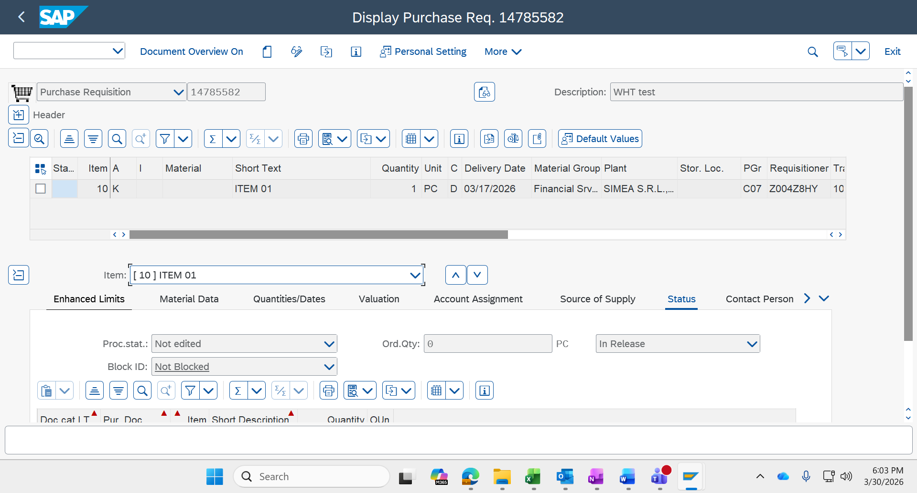

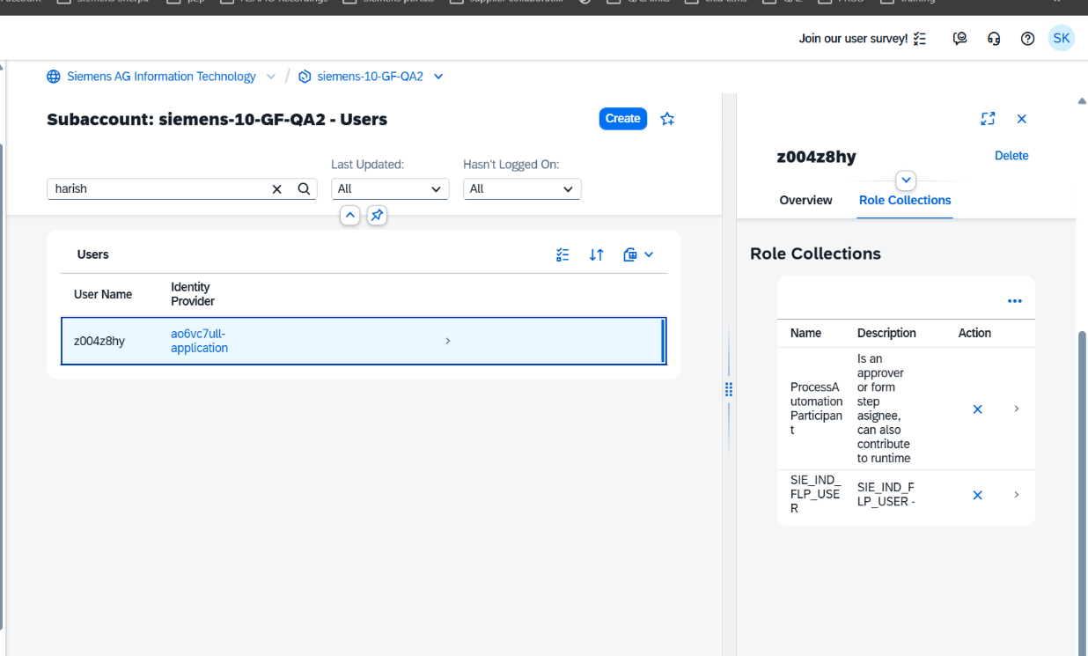

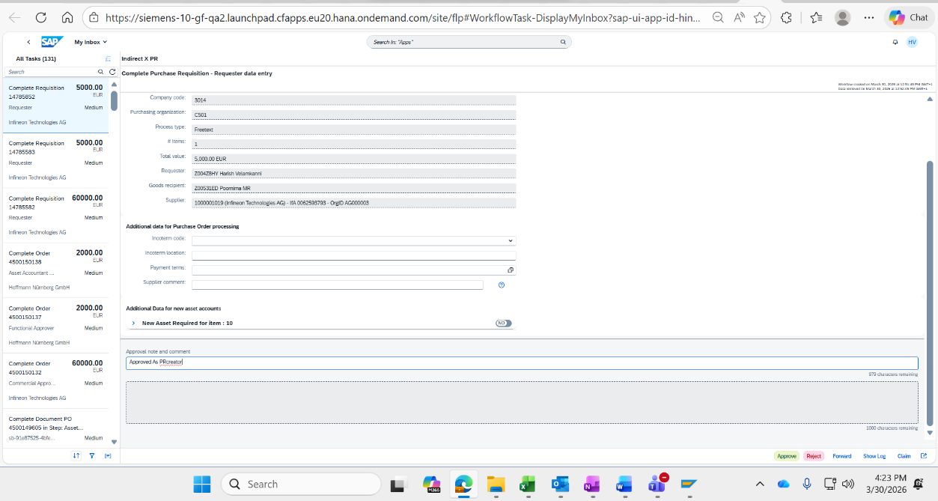

Tested for Another PR – 14785844 with GID : Z0046D7W and All the Roles are removed for User : Z004Z8HY (Purchaser)

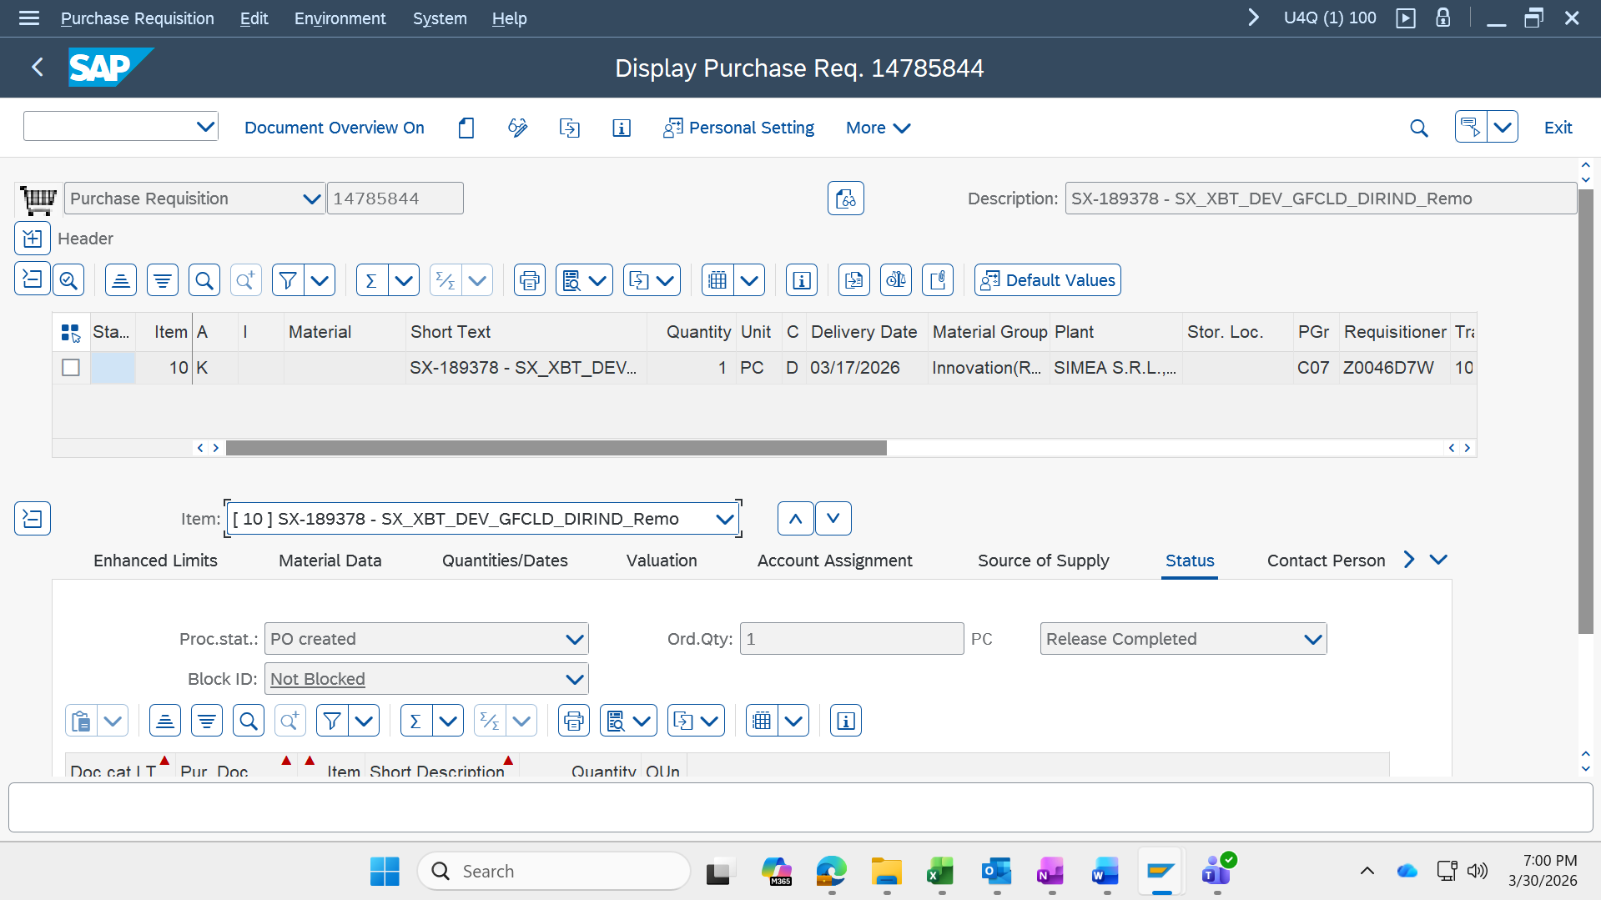

Purchaser : Z004Z8HY receving procurement Verification notification
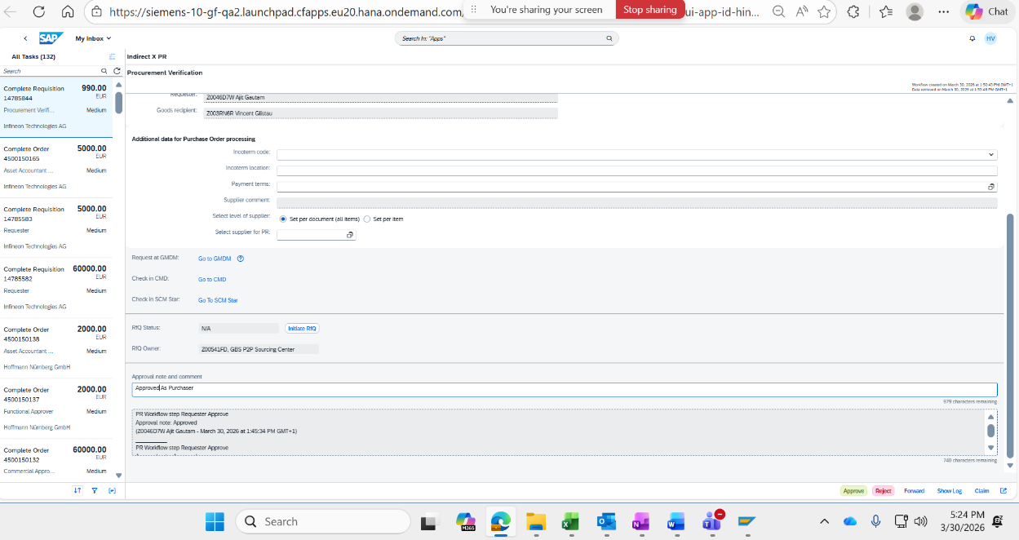
End user cannot see Process Visibility app , but can check Workflow Visibility app

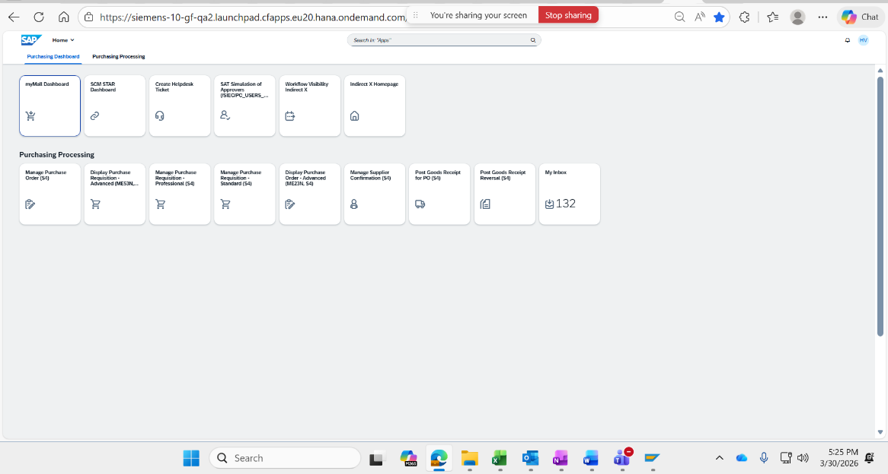

Access to Workflow Visibility IndirectX App
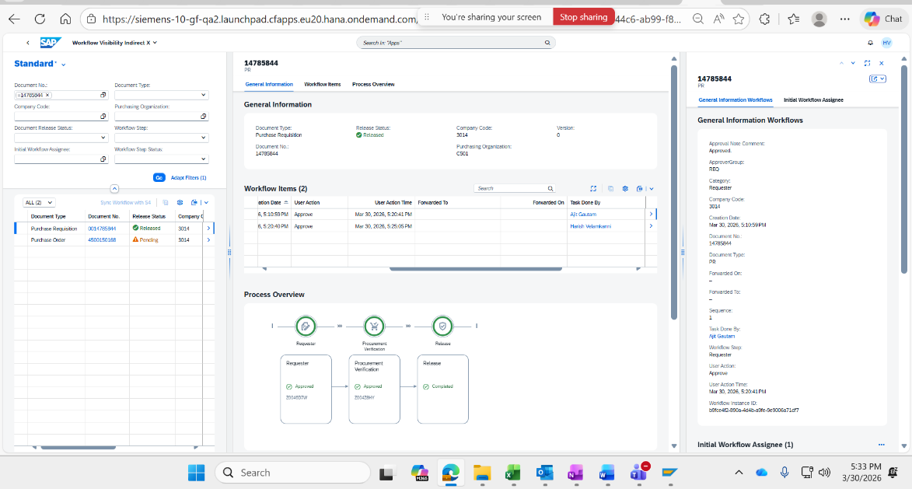

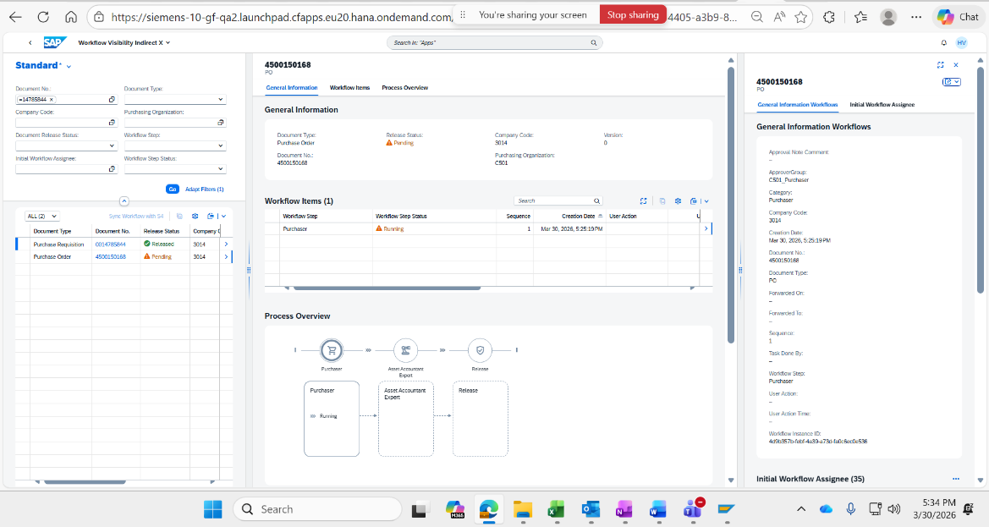

Admin User :

User Management

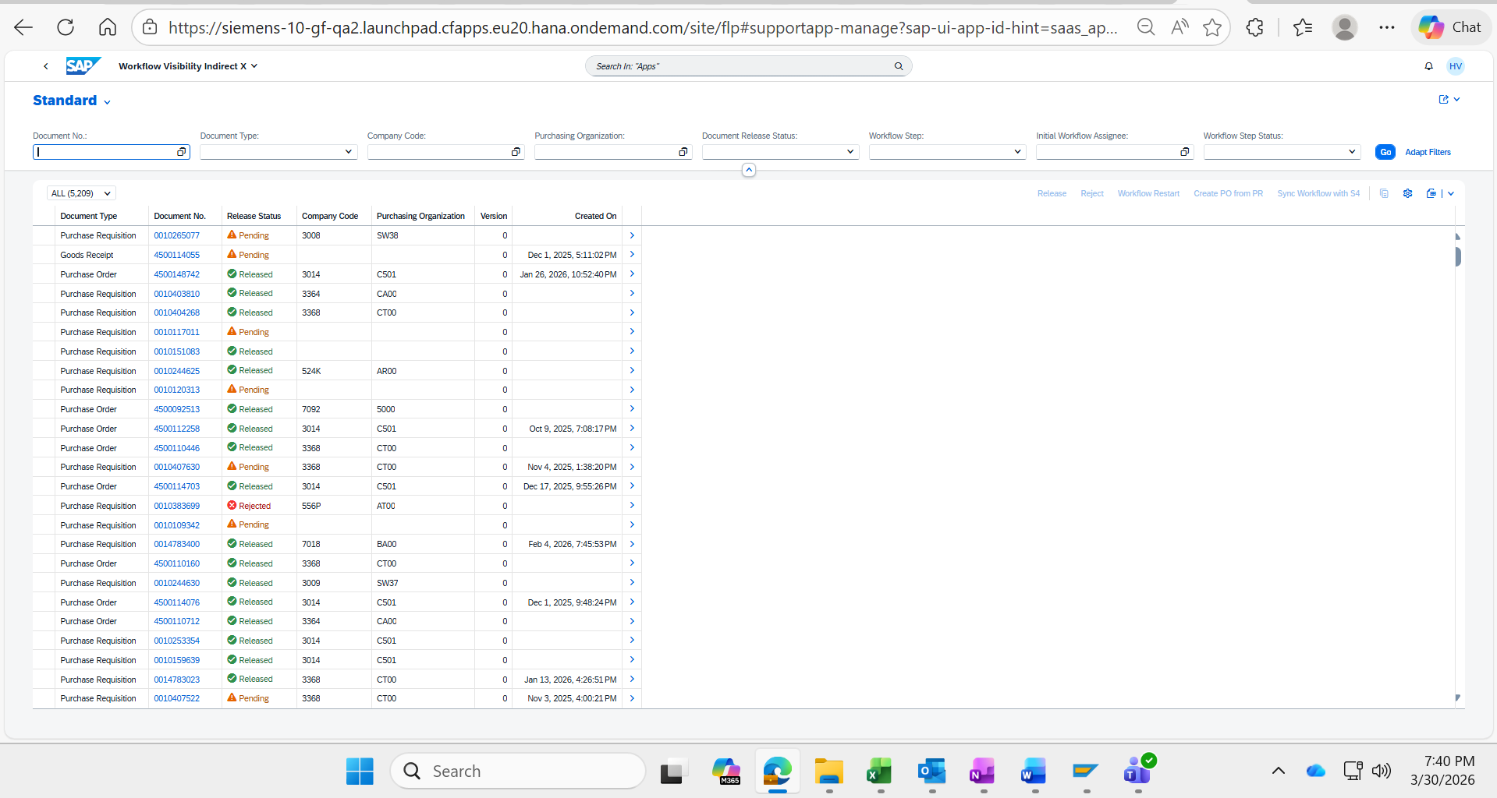
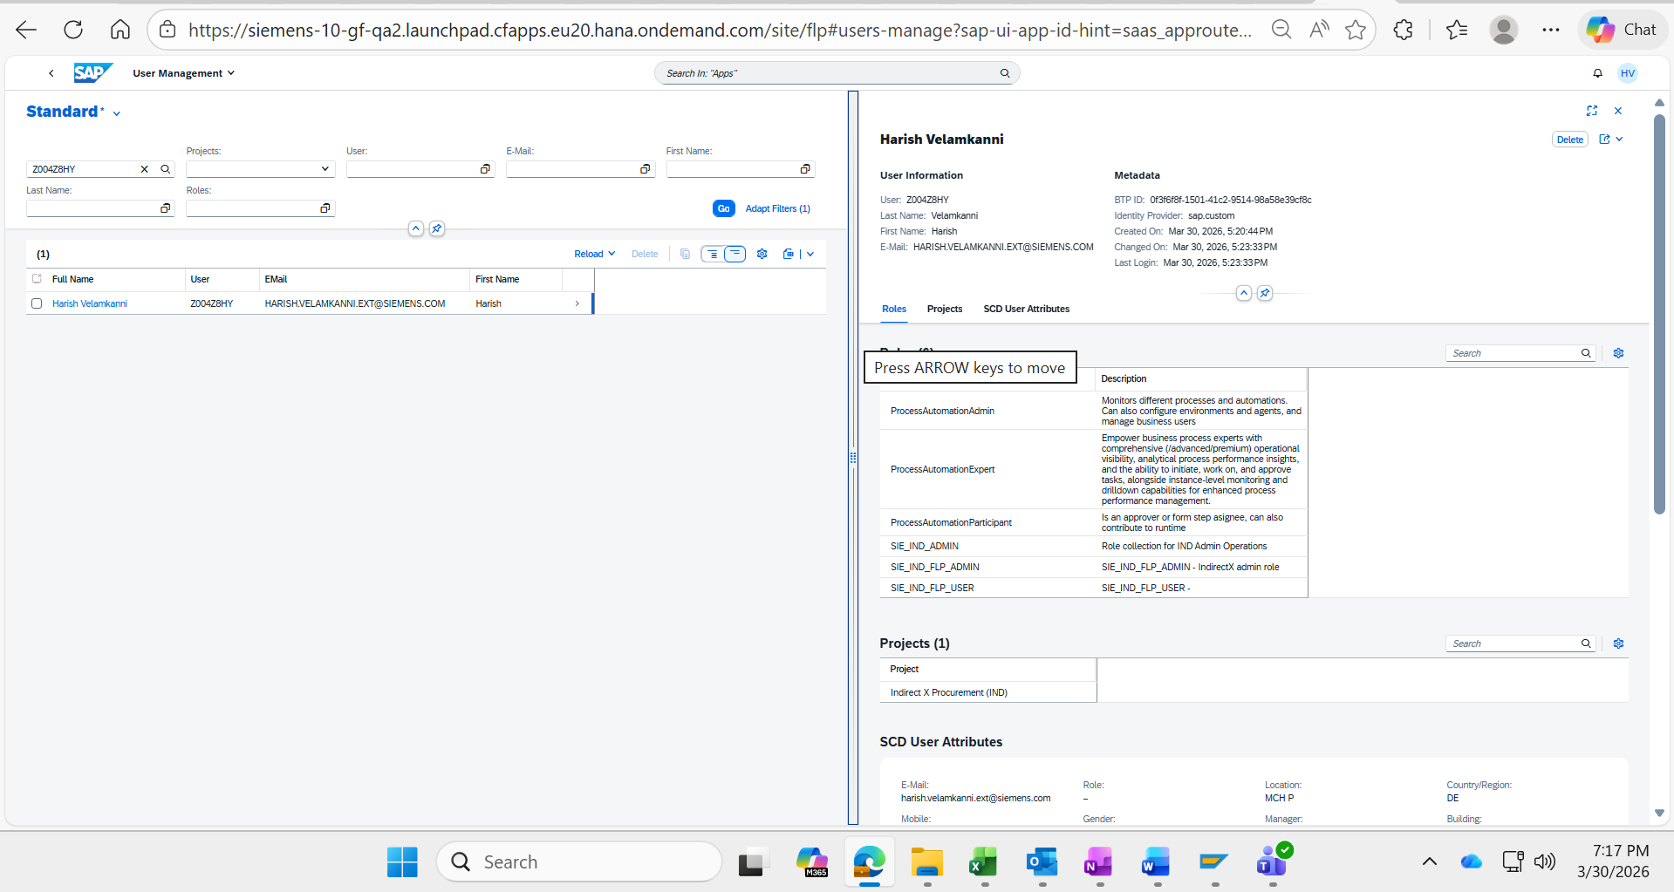

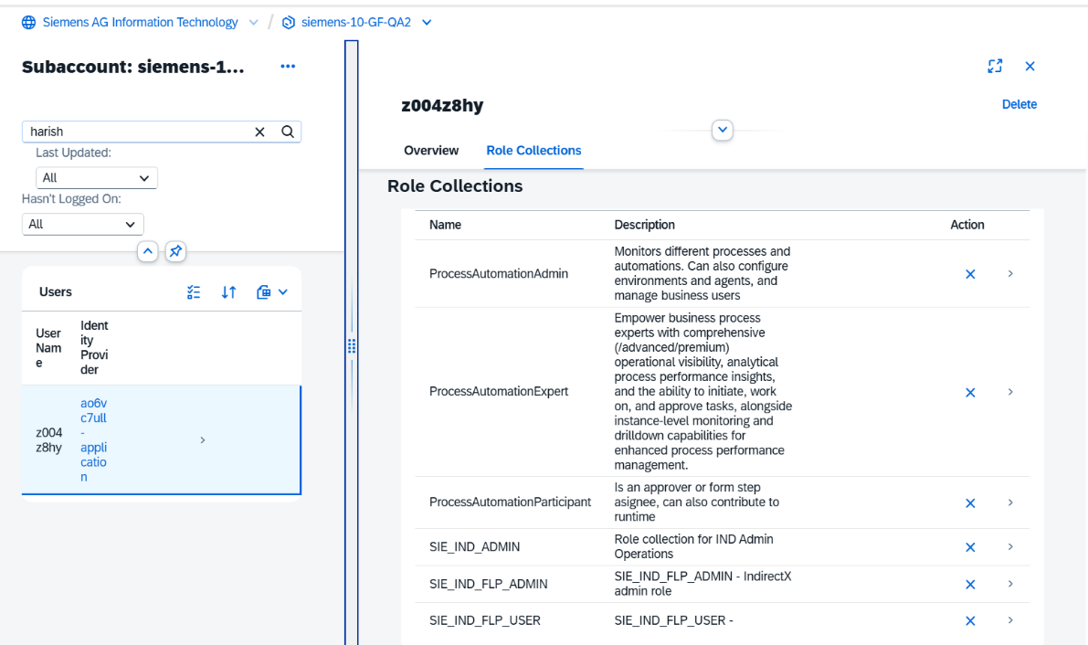

End user can access Process Visibility apps

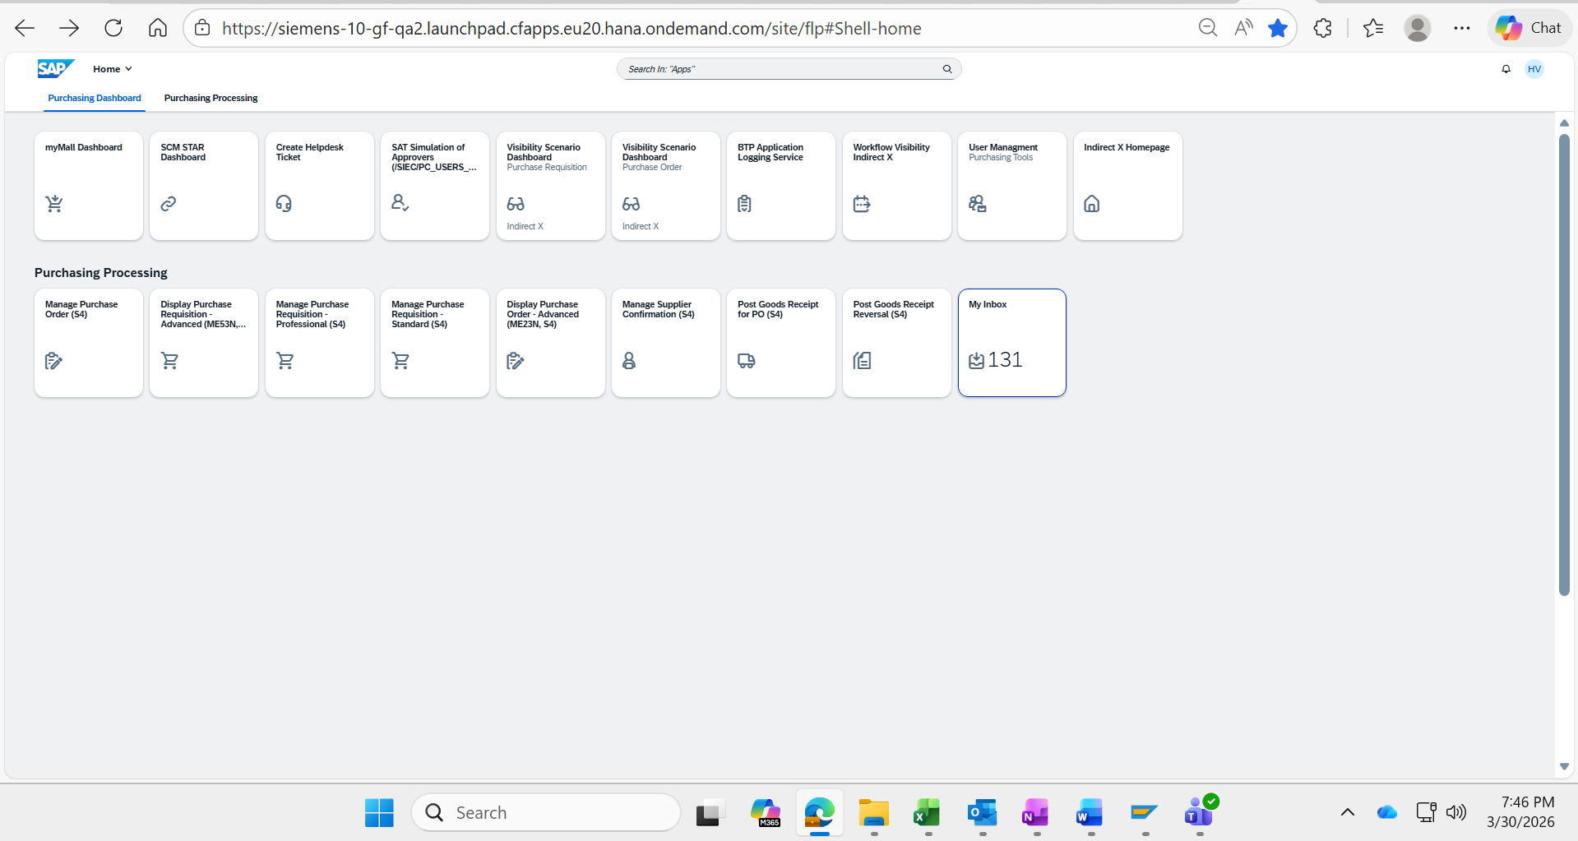

PR Visibility Dashboard:
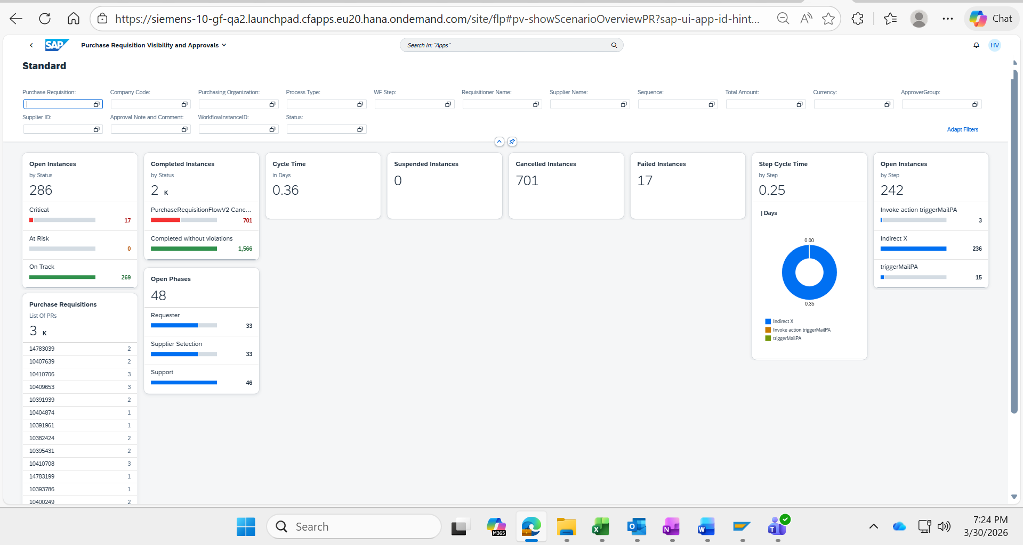

PO Visibility Dashboard :

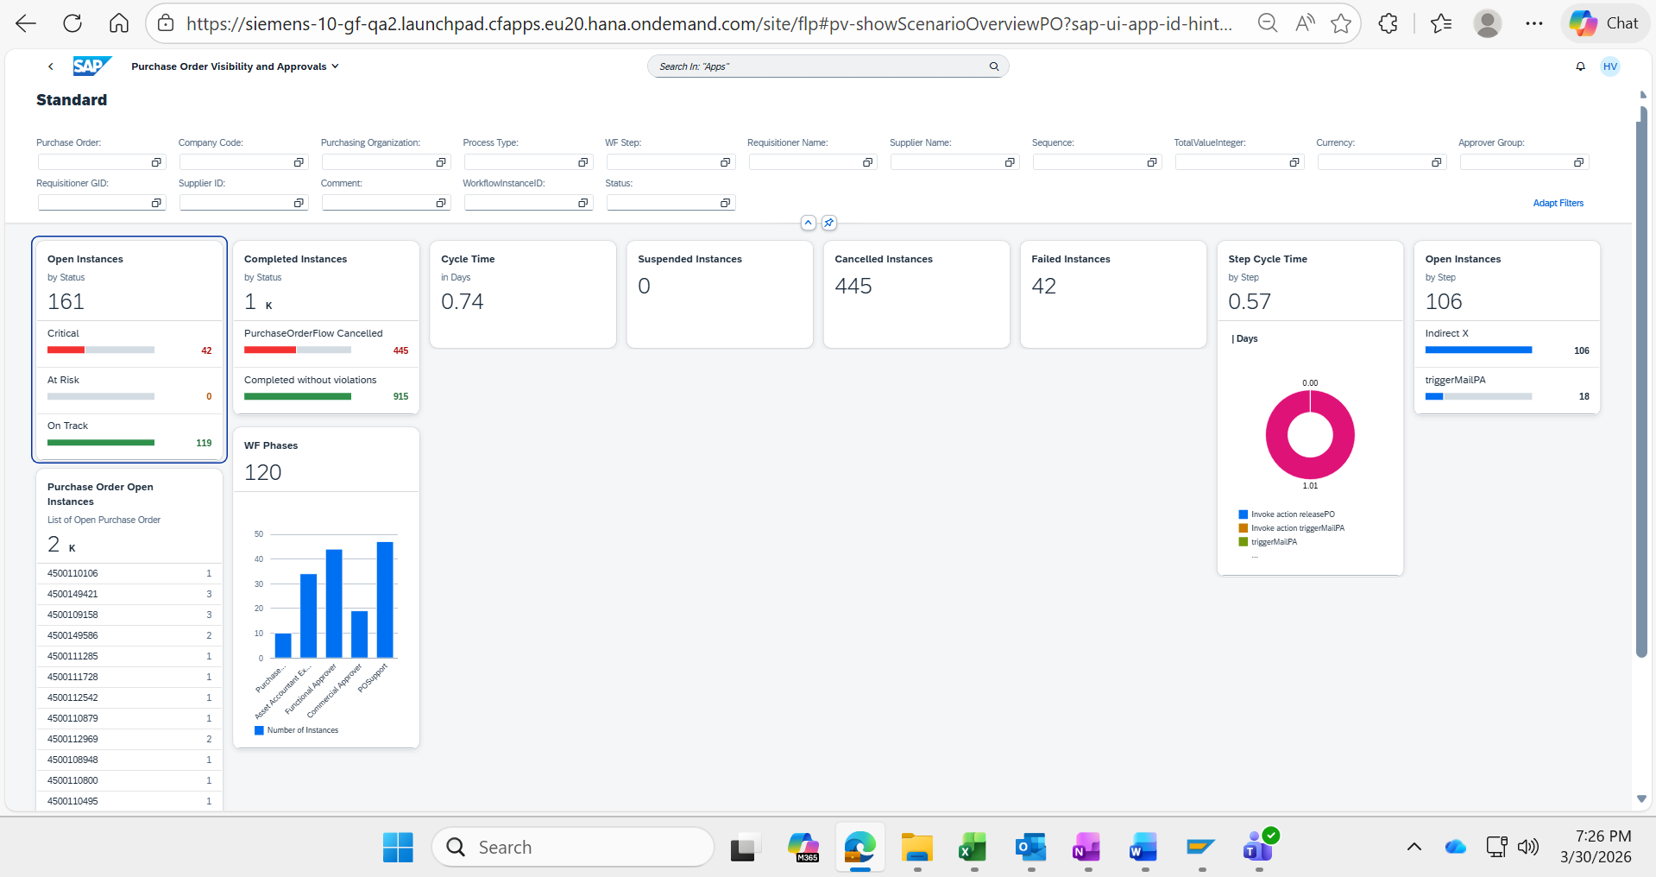

BTP Application Logging Service

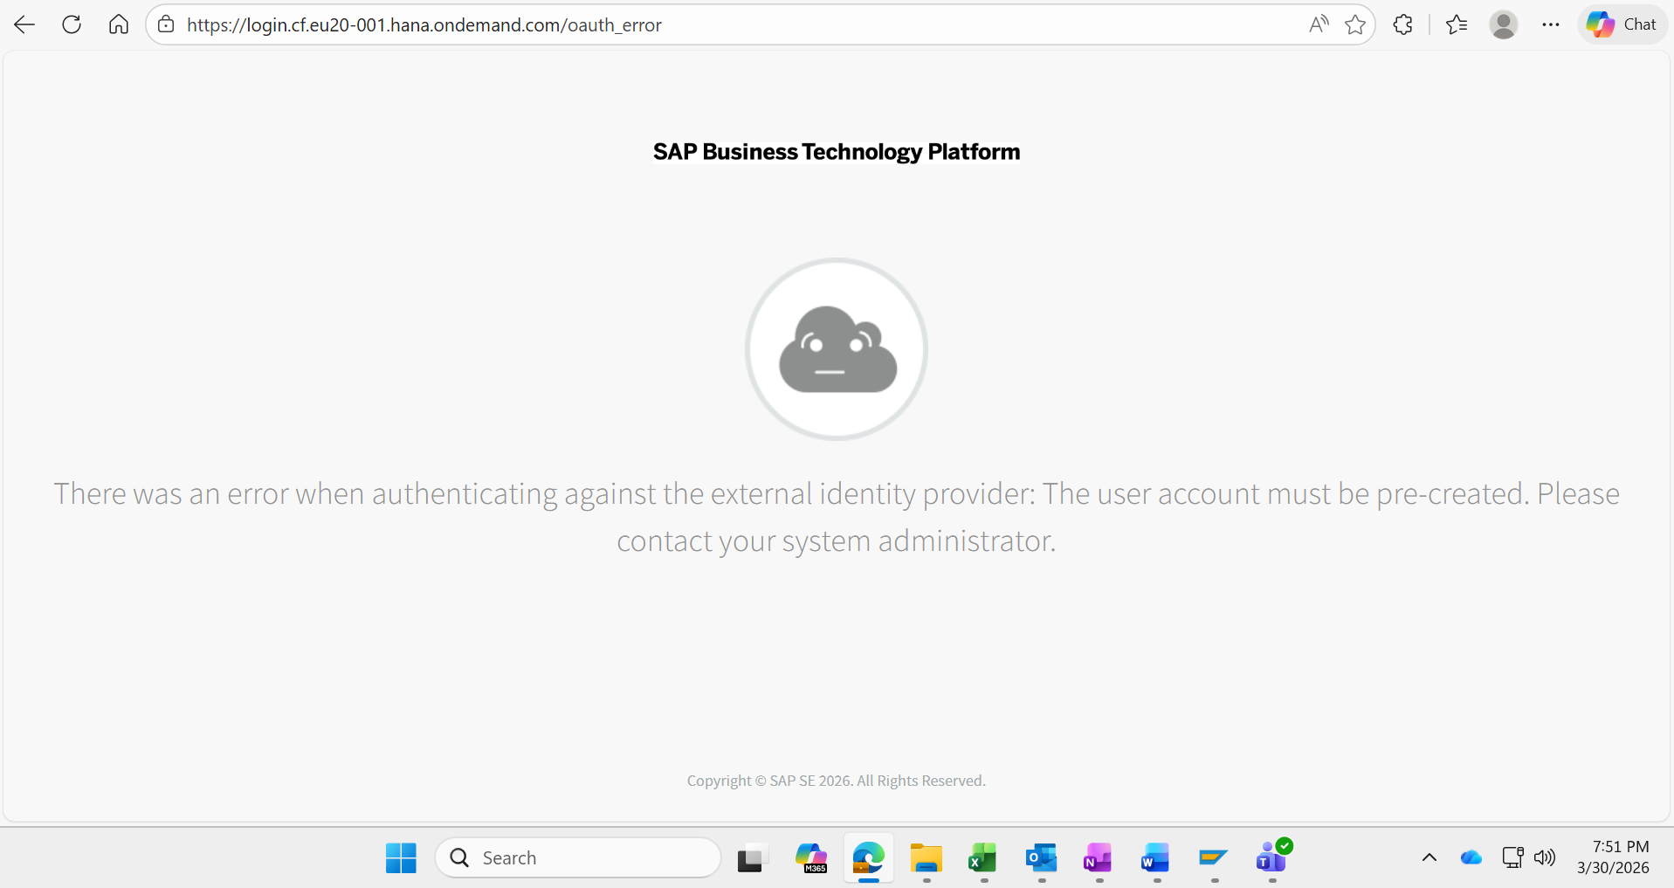

Test was successful  Please attach screenshots of the configuration. | ☒
Test was not successful  Please attach a screenshot of the result and any error messages.  Consider a new test. Test document should be enhanced by another test case. | ☐

